NAME : NISHITA MANAHRSINH SOLANKI

ROLL NO.: 22BCE211

SUBJECT : DEVOPS

PRACTICAL – 9 DEVSECOPS

**Overview**

Binary Authorization is a deploy-time security control that ensures only trusted container images are deployed on Google Kubernetes Engine (GKE) or Cloud Run. With Binary Authorization, you can require images to be signed by trusted authorities during the development process and then enforce signature validation when deploying. By enforcing validation, you can gain tighter control over your container environment by ensuring only verified images are integrated into the build-and-release process.

The following diagram shows the components in a Binary Authorization/Cloud Build setup:

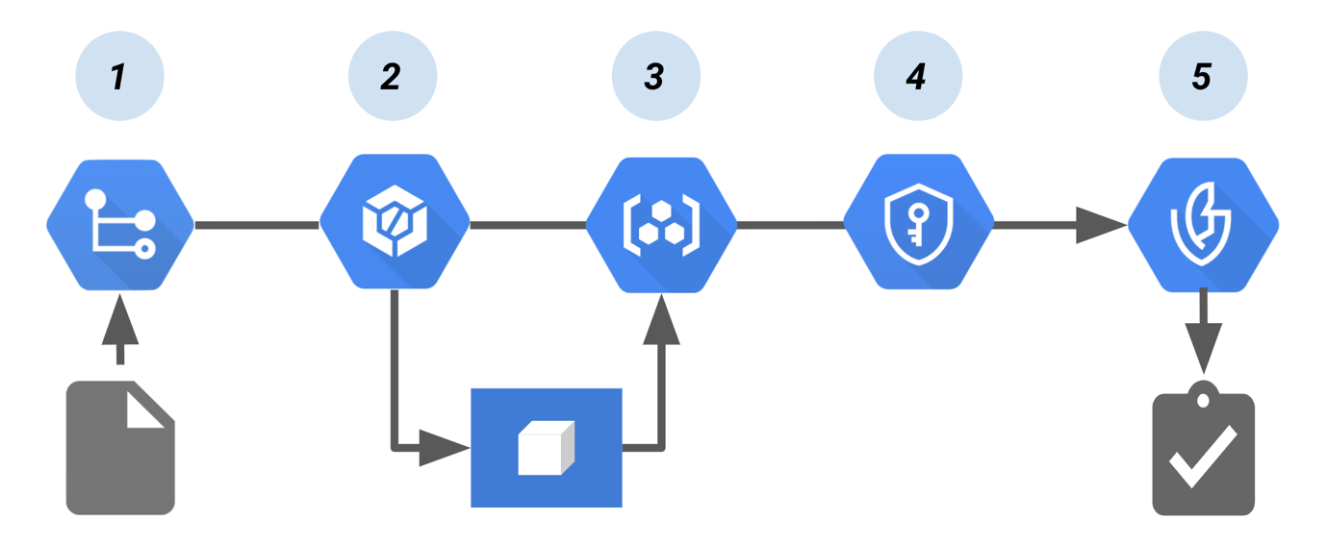Cloud Build pipeline that creates a Binary Authorization attestation.

In this pipeline:

1. Code to build the container image is pushed to a source repository, such as [Cloud Source Repositories](https://cloud.google.com/source-repositories/docs).
2. A continuous integration (CI) tool, [Cloud Build](https://cloud.google.com/build/docs) builds and tests the container.
3. The build pushes the container image to [Container Registry](https://cloud.google.com/container-registry/docs) or another registry that stores your built images.
4. [Cloud Key Management Service](https://cloud.google.com/kms/docs), which provides key management for the [cryptographic key pair](https://cloud.google.com/binary-authorization/docs/key-concepts#cryptographic_keys), signs the container image. The resulting signature is then stored in a newly created attestation.
5. At deploy time, the attestor verifies the attestation using the public key from the key pair. [Binary Authorization](https://cloud.google.com/binary-authorization/docs) enforces the [policy](https://cloud.google.com/binary-authorization/docs/key-concepts#policies) by requiring signed [attestations](https://cloud.google.com/binary-authorization/docs/key-concepts#attestations) to deploy the container image.

In this lab you will learn about the tools and techniques to secure deployed artifacts. This lab focuses on artifacts (containers) after they have been created but not deployed to any particular environment.

What you'll learn

* Image Signing
* Admission Control Policies
* Signing Scanned Images
* Authorizing Signed Images
* Blocked unsigned Images

**Setup and requirements**

Before you click the Start Lab button

Read these instructions. Labs are timed and you cannot pause them. The timer, which starts when you click **Start Lab**, shows how long Google Cloud resources will be made available to you.

This hands-on lab lets you do the lab activities yourself in a real cloud environment, not in a simulation or demo environment. It does so by giving you new, temporary credentials that you use to sign in and access Google Cloud for the duration of the lab.

To complete this lab, you need:

* Access to a standard internet browser (Chrome browser recommended).

**Note:** Use an Incognito or private browser window to run this lab. This prevents any conflicts between your personal account and the Student account, which may cause extra charges incurred to your personal account.

* Time to complete the lab---remember, once you start, you cannot pause a lab.

**Note:** If you already have your own personal Google Cloud account or project, do not use it for this lab to avoid extra charges to your account.

**How to start your lab and sign in to the Google Cloud Console**

1. Click the **Start Lab** button. If you need to pay for the lab, a pop-up opens for you to select your payment method. On the left is a panel populated with the temporary credentials that you must use for this lab.

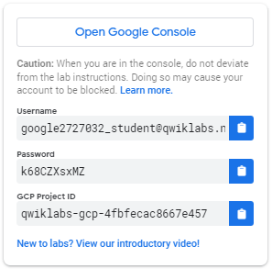

1. Copy the username, and then click **Open Google Console**. The lab spins up resources, and then opens another tab that shows the **Sign in** page.

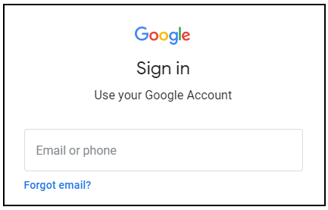

***Tip:*** Open the tabs in separate windows, side-by-side.

If you see the **Choose an account** page, click **Use Another Account**.  
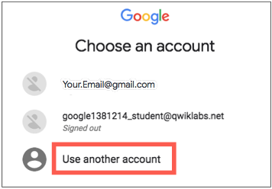

1. In the **Sign in** page, paste the username that you copied from the left panel. Then copy and paste the password.

***Important:*** You must use the credentials from the left panel. Do not use your Google Cloud Training credentials. If you have your own Google Cloud account, do not use it for this lab (avoids incurring charges).

1. Click through the subsequent pages:
   * Accept the terms and conditions.
   * Do not add recovery options or two-factor authentication (because this is a temporary account).
   * Do not sign up for free trials.

After a few moments, the Cloud Console opens in this tab.

**Note:** You can view the menu with a list of Google Cloud Products and Services by clicking the **Navigation menu** at the top-left. 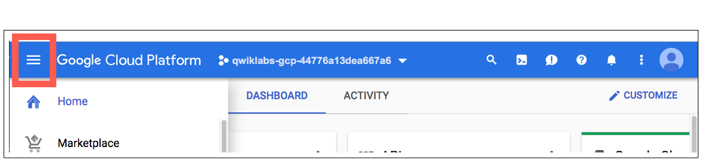

Activate Cloud Shell

Cloud Shell is a virtual machine that is loaded with development tools. It offers a persistent 5GB home directory and runs on the Google Cloud. Cloud Shell provides command-line access to your Google Cloud resources.

In the Cloud Console, in the top right toolbar, click the **Activate Cloud Shell** button.

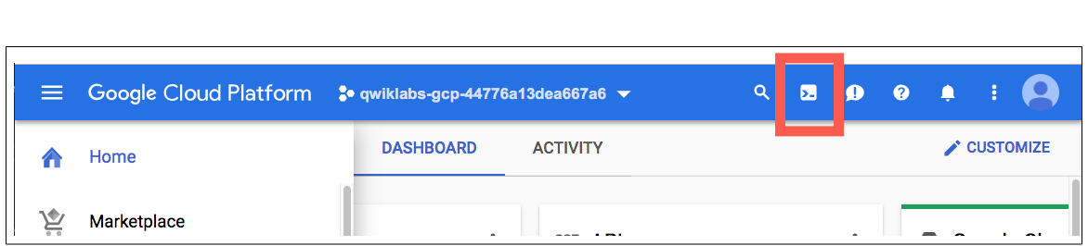

Click **Continue**.

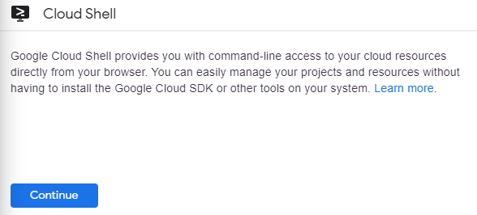

It takes a few moments to provision and connect to the environment. When you are connected, you are already authenticated, and the project is set to your *PROJECT\_ID*. For example:

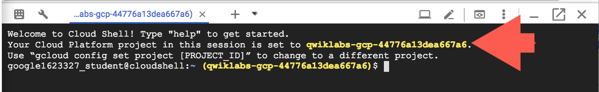

gcloud is the command-line tool for Google Cloud. It comes pre-installed on Cloud Shell and supports tab-completion.

You can list the active account name with this command:

gcloud auth list

Copied!

(Output)

Credentialed accounts:

- <myaccount>@<mydomain>.com (active)

(Example output)

Credentialed accounts:

- google1623327\_student@qwiklabs.net

You can list the project ID with this command:

gcloud config list project

Copied!

(Output)

[core]

project = <project\_ID>

(Example output)

[core]

project = qwiklabs-gcp-44776a13dea667a6

For full documentation of gcloud see the [gcloud command-line tool overview](https://cloud.google.com/sdk/gcloud" \t "_blank).

Environment Setup

In Cloud Shell, set your project ID and the project number for your project. Save them as PROJECT\_ID and PROJECT\_NUMBER variables.

export PROJECT\_ID=$(gcloud config get-value project)

export PROJECT\_NUMBER=$(gcloud projects describe $PROJECT\_ID \

--format='value(projectNumber)')

Copied!

Enable services

Enable all necessary services:

gcloud services enable \

cloudkms.googleapis.com \

cloudbuild.googleapis.com \

container.googleapis.com \

containerregistry.googleapis.com \

artifactregistry.googleapis.com \

containerscanning.googleapis.com \

ondemandscanning.googleapis.com \

binaryauthorization.googleapis.com

Copied!

**Task 1. Create Artifact Registry repository**

In this lab you will be using Artifact Registry to store and scan your images.

1. Create the repository with the following command:

gcloud artifacts repositories create artifact-scanning-repo \

--repository-format=docker \

--location=europe-west1 \

--description="Docker repository"

Copied!

1. Configure docker to utilize your gcloud credentials when accessing Artifact Registry:

gcloud auth configure-docker europe-west1-docker.pkg.dev

Copied!

1. Create and change into a work directory:

mkdir vuln-scan && cd vuln-scan

Copied!

1. Next define a sample image. Create a file called Dockerfile with the following contents:

cat > ./Dockerfile << EOF

FROM python:3.8-alpine

# App

WORKDIR /app

COPY . ./

RUN pip3 install Flask==2.1.0

RUN pip3 install gunicorn==20.1.0

RUN pip3 install Werkzeug==2.2.2

CMD exec gunicorn --bind :\$PORT --workers 1 --threads 8 main:app

EOF

Copied!

1. Create a file called main.py with the following contents:

cat > ./main.py << EOF

import os

from flask import Flask

app = Flask(\_\_name\_\_)

@app.route("/")

def hello\_world():

name = os.environ.get("NAME", "Worlds")

return "Hello {}!".format(name)

if \_\_name\_\_ == "\_\_main\_\_":

app.run(debug=True, host="0.0.0.0", port=int(os.environ.get("PORT", 8080)))

EOF

Copied!

1. Use Cloud Build to build and automatically push your container to Artifact Registry.

gcloud builds submit . -t europe-west1-docker.pkg.dev/${PROJECT\_ID}/artifact-scanning-repo/sample-image

Copied!

Click **Check my progress** to verify the objective.

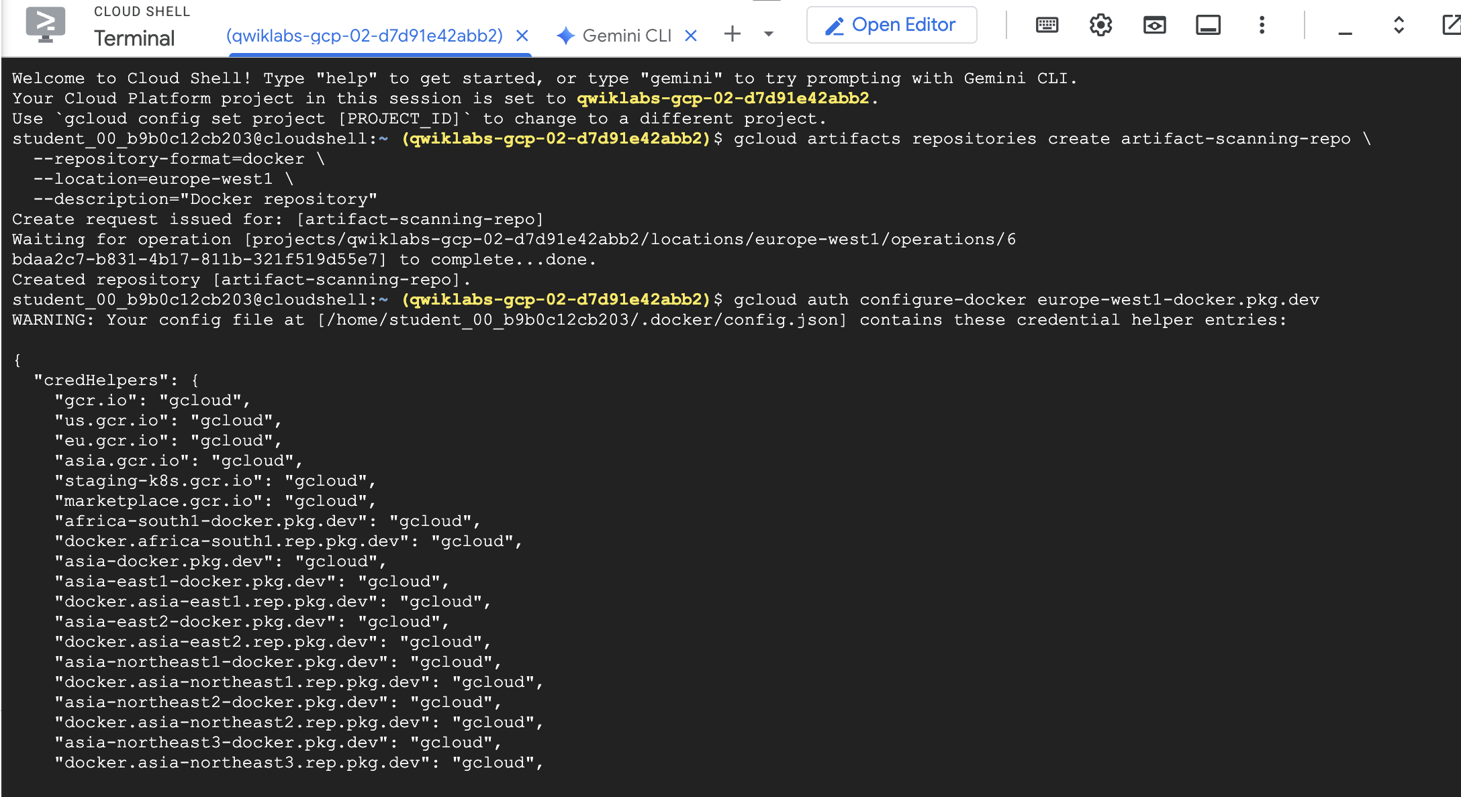 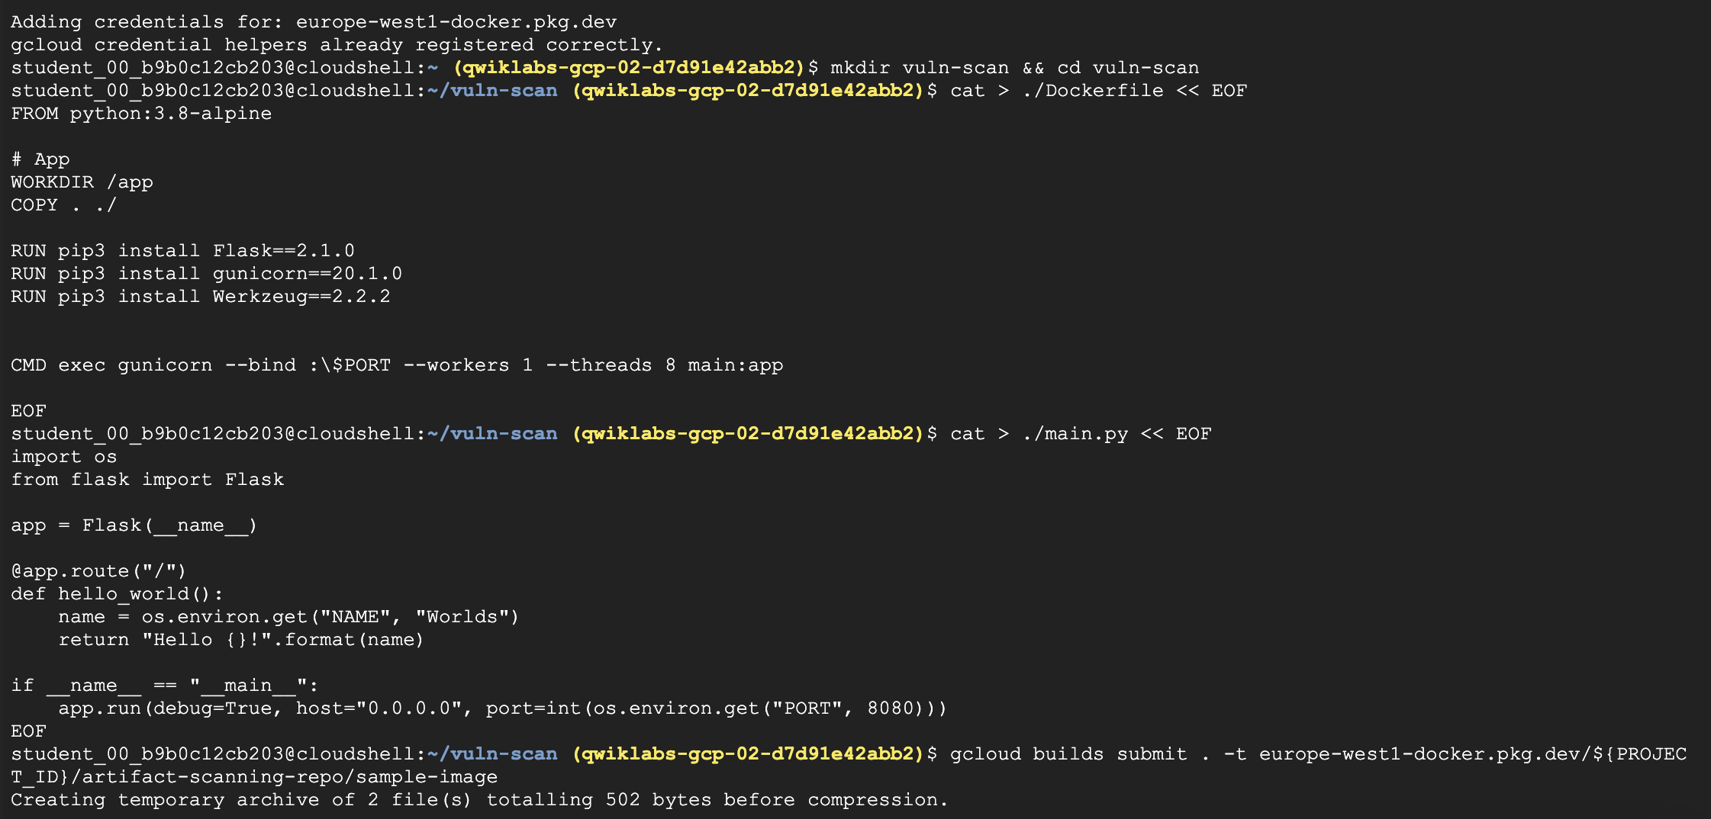 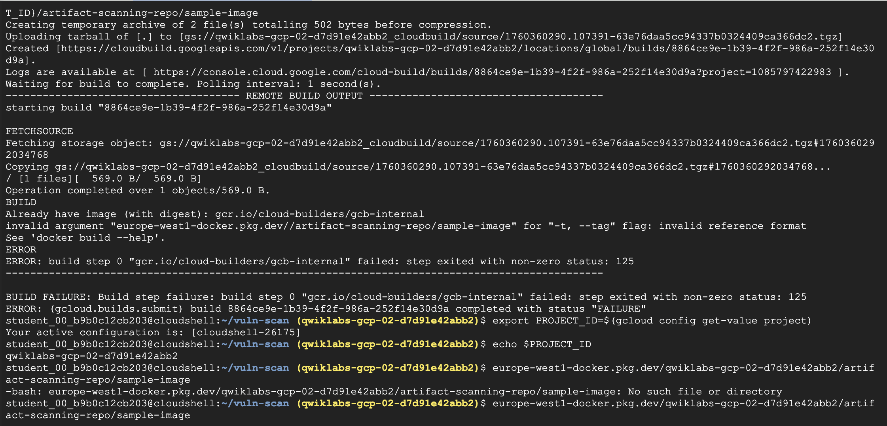 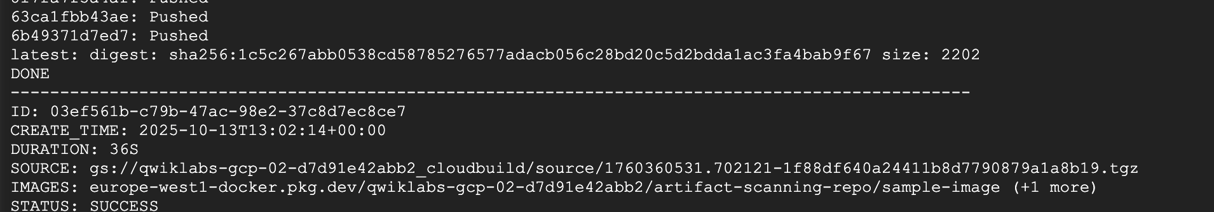

**Task 2. Image Signing**

What is an Attestor

* This person/process is responsible for one link in the chain of trust of the system.
* They hold a cryptographic key, and sign an image if it passes their approval process.
* While the Policy Creator determines policy in a high-level, abstract way, the Attestor is responsible for concretely enforcing some aspect of the policy.
* This can be a real person, like a QA tester or a manager, or a bot in a CI system.
* The security of the system depends on their trustworthiness, so it's important that their private keys are kept secure.

Each of these roles can represent an individual person or a team of people in your organization. In a production environment, these roles would likely be managed by separate Google Cloud Platform projects, and access to resources would be shared between them in a limited fashion using [Cloud IAM](https://cloud.google.com/iam/).

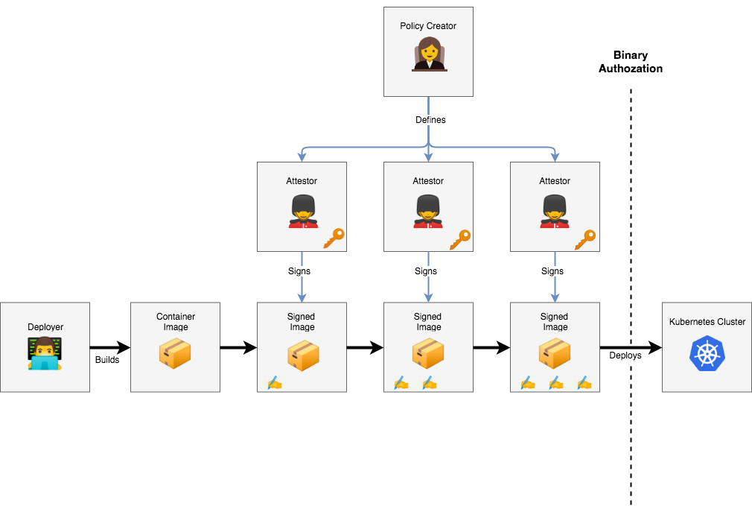

Attestors in Binary Authorization are implemented on top of the [Cloud Container Analysis API](https://cloud.google.com/container-analysis/api/reference/rest/), so it is important to describe how that works before going forward. The Container Analysis API was designed to allow you to associate metadata with specific container images.

As an example, a Note might be created to track the [Heartbleed](http://heartbleed.com/) vulnerability. Security vendors would then create scanners to test container images for the vulnerability, and create an Occurrence associated with each compromised container.

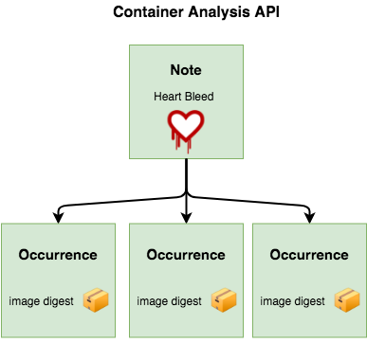

Along with tracking vulnerabilities, Container Analysis was designed to be a generic metadata API. Binary Authorization utilizes Container Analysis to associate signatures with the container images they are verifying. A Container Analysis Note is used to represent a single attestor, and Occurrences are created and associated with each container that attestor has approved.

The Binary Authorization API uses the concepts of "attestors" and "attestations", but these are implemented using corresponding Notes and Occurrences in the Container Analysis API.

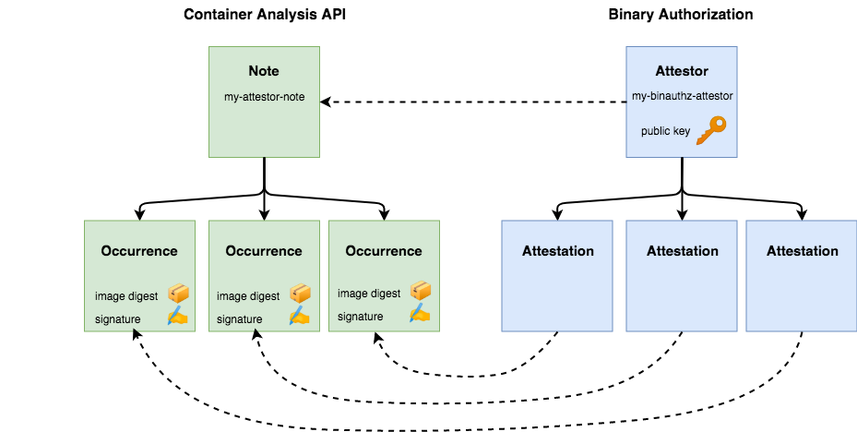

Create an Attestor Note

An Attestor Note is simply a small bit of data that acts as a label for the type of signature being applied. For example one note might indicate vulnerability scan, while another might be used for QA sign off. The note will be referred to during the signing process.

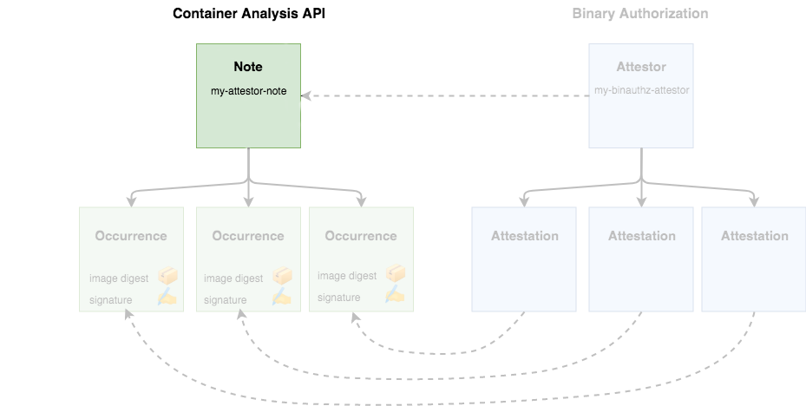

1. Create a note:

cat > ./vulnz\_note.json << EOM

{

"attestation": {

"hint": {

"human\_readable\_name": "Container Vulnerabilities attestation authority"

}

}

}

EOM

Copied!

1. Store the note

NOTE\_ID=vulnz\_note

curl -vvv -X POST \

-H "Content-Type: application/json" \

-H "Authorization: Bearer $(gcloud auth print-access-token)" \

--data-binary @./vulnz\_note.json \

"https://containeranalysis.googleapis.com/v1/projects/${PROJECT\_ID}/notes/?noteId=${NOTE\_ID}"

Copied!

1. Verify the note

curl -vvv \

-H "Authorization: Bearer $(gcloud auth print-access-token)" \

"https://containeranalysis.googleapis.com/v1/projects/${PROJECT\_ID}/notes/${NOTE\_ID}"

Copied!

Your Note is now saved within the Container Analysis API.

1. Creating an Attestor

Attestors are used to perform the actual image signing process and will attach an occurrence of the note to the image for later verification. To make use of your attestor, you must also register the note with Binary Authorization:

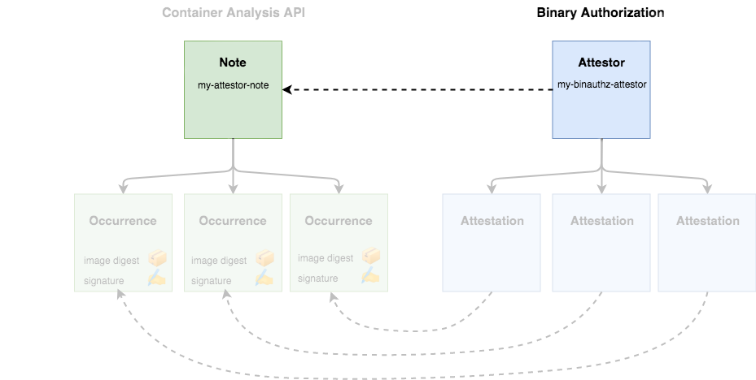

1. Create Attestor

ATTESTOR\_ID=vulnz-attestor

gcloud container binauthz attestors create $ATTESTOR\_ID \

--attestation-authority-note=$NOTE\_ID \

--attestation-authority-note-project=${PROJECT\_ID}

Copied!

1. Verify Attestor

gcloud container binauthz attestors list

Copied!

The last line indicates NUM\_PUBLIC\_KEYS: 0 you will provide keys in a later step.

Cloud Build automatically creates the built-by-cloud-build attestor in your project when you run a build that generates images. So the above command returns two attestors, vulnz-attestor and built-by-cloud-build. After images are successfully built, Cloud Build automatically signs and creates attestations for them.

1. The [Binary Authorization](https://cloud.google.com/binary-authorization/docs/overview) service account will need rights to view the attestation notes. Provide the access to the IAM Role with the following API call:

PROJECT\_NUMBER=$(gcloud projects describe "${PROJECT\_ID}" --format="value(projectNumber)")

BINAUTHZ\_SA\_EMAIL="service-${PROJECT\_NUMBER}@gcp-sa-binaryauthorization.iam.gserviceaccount.com"

cat > ./iam\_request.json << EOM

{

'resource': 'projects/${PROJECT\_ID}/notes/${NOTE\_ID}',

'policy': {

'bindings': [

{

'role': 'roles/containeranalysis.notes.occurrences.viewer',

'members': [

'serviceAccount:${BINAUTHZ\_SA\_EMAIL}'

]

}

]

}

}

EOM

Copied!

1. Use the file to create the IAM Policy:

curl -X POST \

-H "Content-Type: application/json" \

-H "Authorization: Bearer $(gcloud auth print-access-token)" \

--data-binary @./iam\_request.json \

"https://containeranalysis.googleapis.com/v1/projects/${PROJECT\_ID}/notes/${NOTE\_ID}:setIamPolicy" 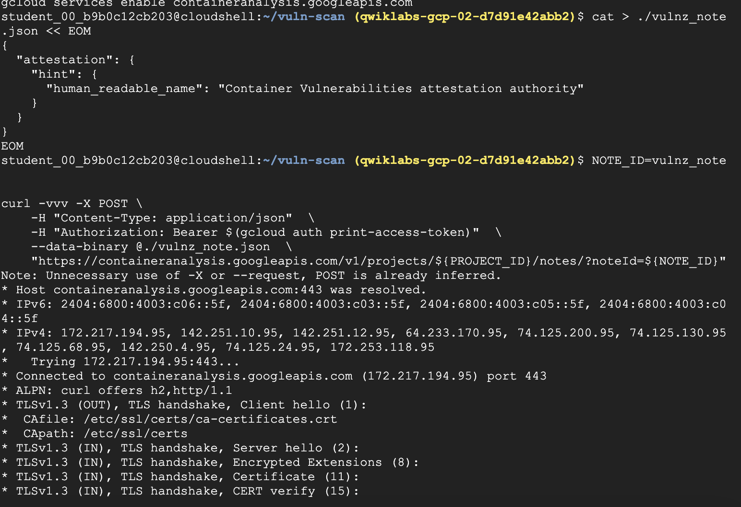 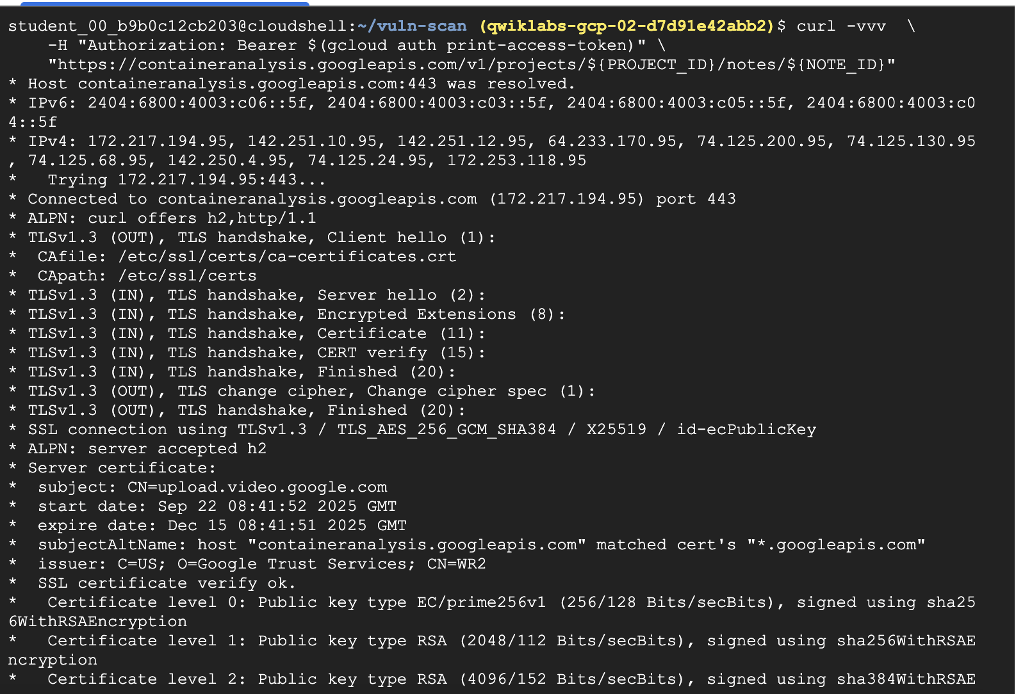 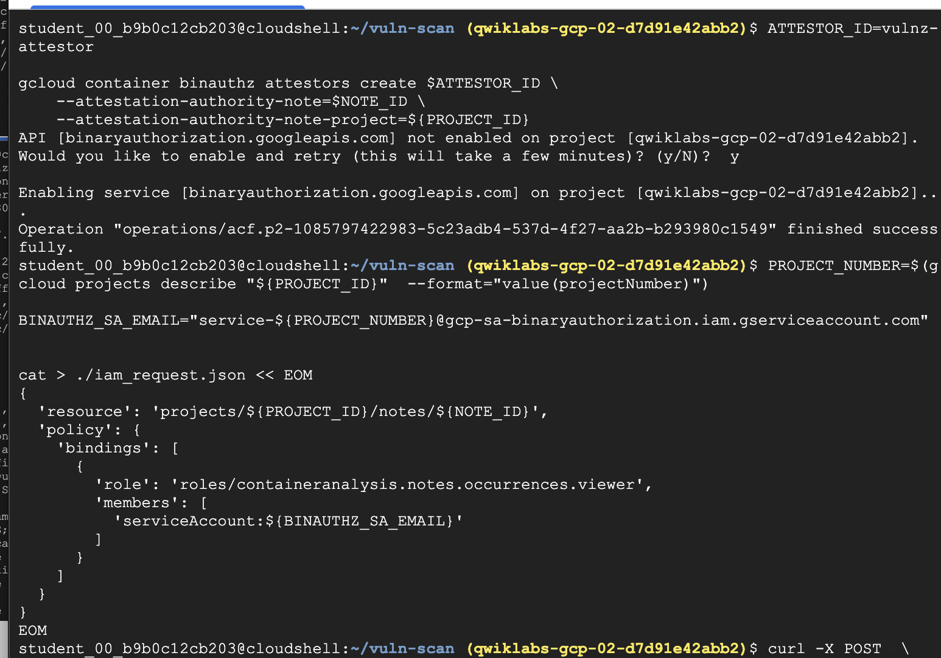 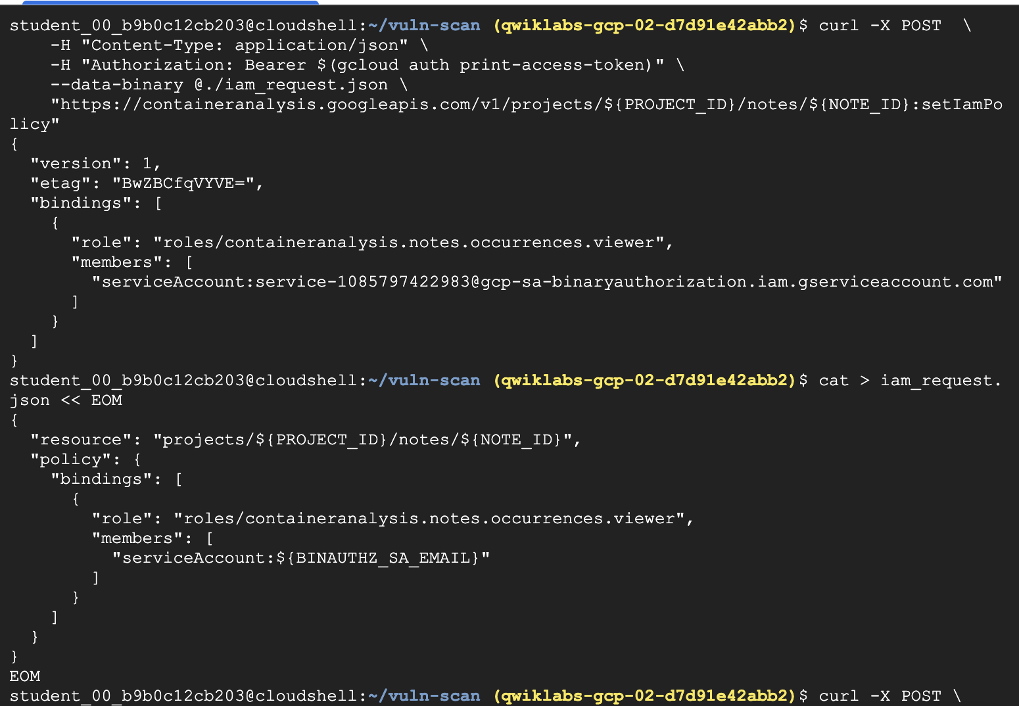 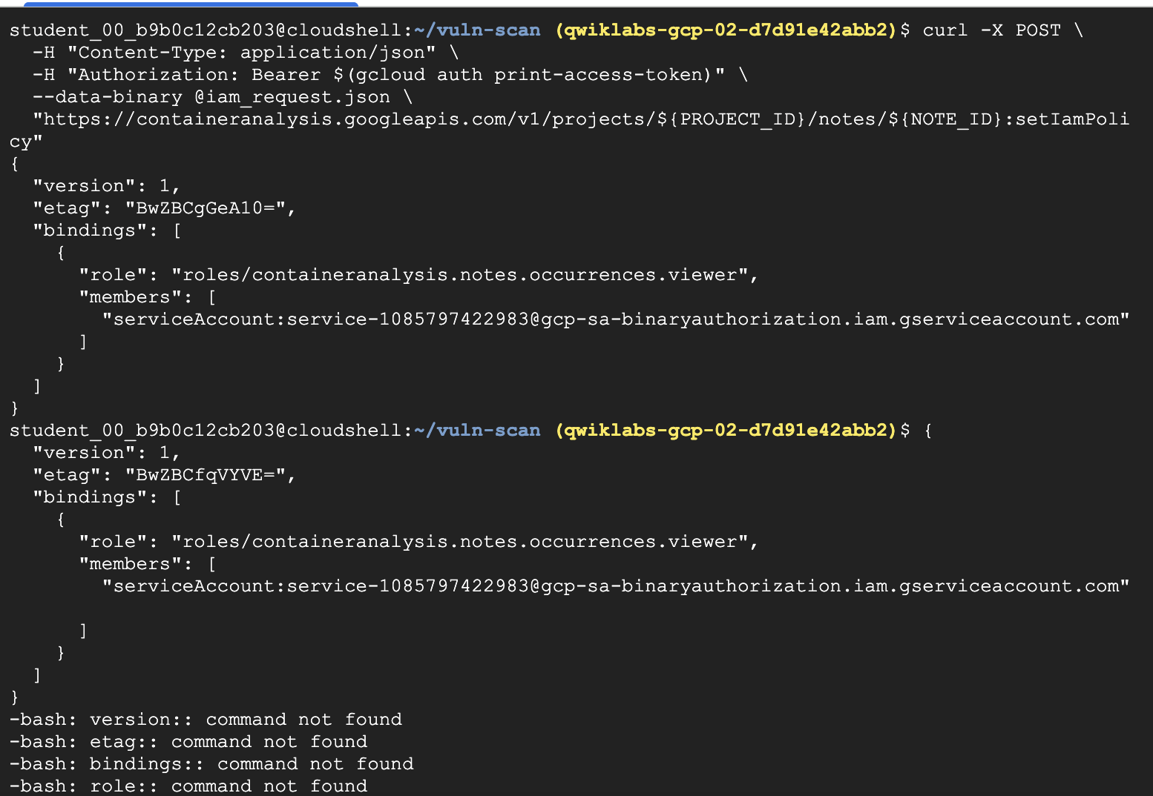

**Task 3. Adding a KMS key**

Before you can use this attestor, your authority needs to create a cryptographic key pair that can be used to sign container images. This can be done through [Google Cloud Key Management Service (KMS)](https://cloud.google.com/kms/).

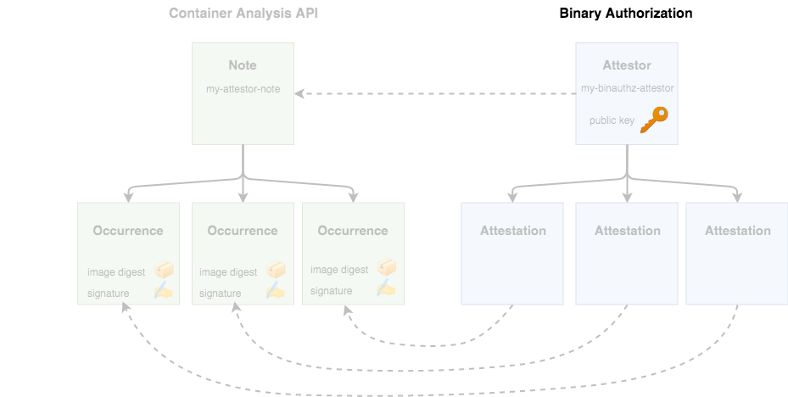

1. First, add some environment variables to describe the new key:

KEY\_LOCATION=global

KEYRING=binauthz-keys

KEY\_NAME=codelab-key

KEY\_VERSION=1

Copied!

1. Create a keyring to hold a set of keys:

gcloud kms keyrings create "${KEYRING}" --location="${KEY\_LOCATION}"

Copied!

1. Create a new asymmetric signing key pair for the attestor

gcloud kms keys create "${KEY\_NAME}" \

--keyring="${KEYRING}" --location="${KEY\_LOCATION}" \

--purpose asymmetric-signing \

--default-algorithm="ec-sign-p256-sha256"

Copied!

You should see your key appear on the [KMS page](https://console.cloud.google.com/security/kms) of theCloud console.

1. Now, associate the key with your attestor through the gcloud binauthz command:

gcloud beta container binauthz attestors public-keys add \

--attestor="${ATTESTOR\_ID}" \

--keyversion-project="${PROJECT\_ID}" \

--keyversion-location="${KEY\_LOCATION}" \

--keyversion-keyring="${KEYRING}" \

--keyversion-key="${KEY\_NAME}" \

--keyversion="${KEY\_VERSION}"

Copied!

1. If you print the list of authorities again, you should now see a key registered:

gcloud container binauthz attestors list

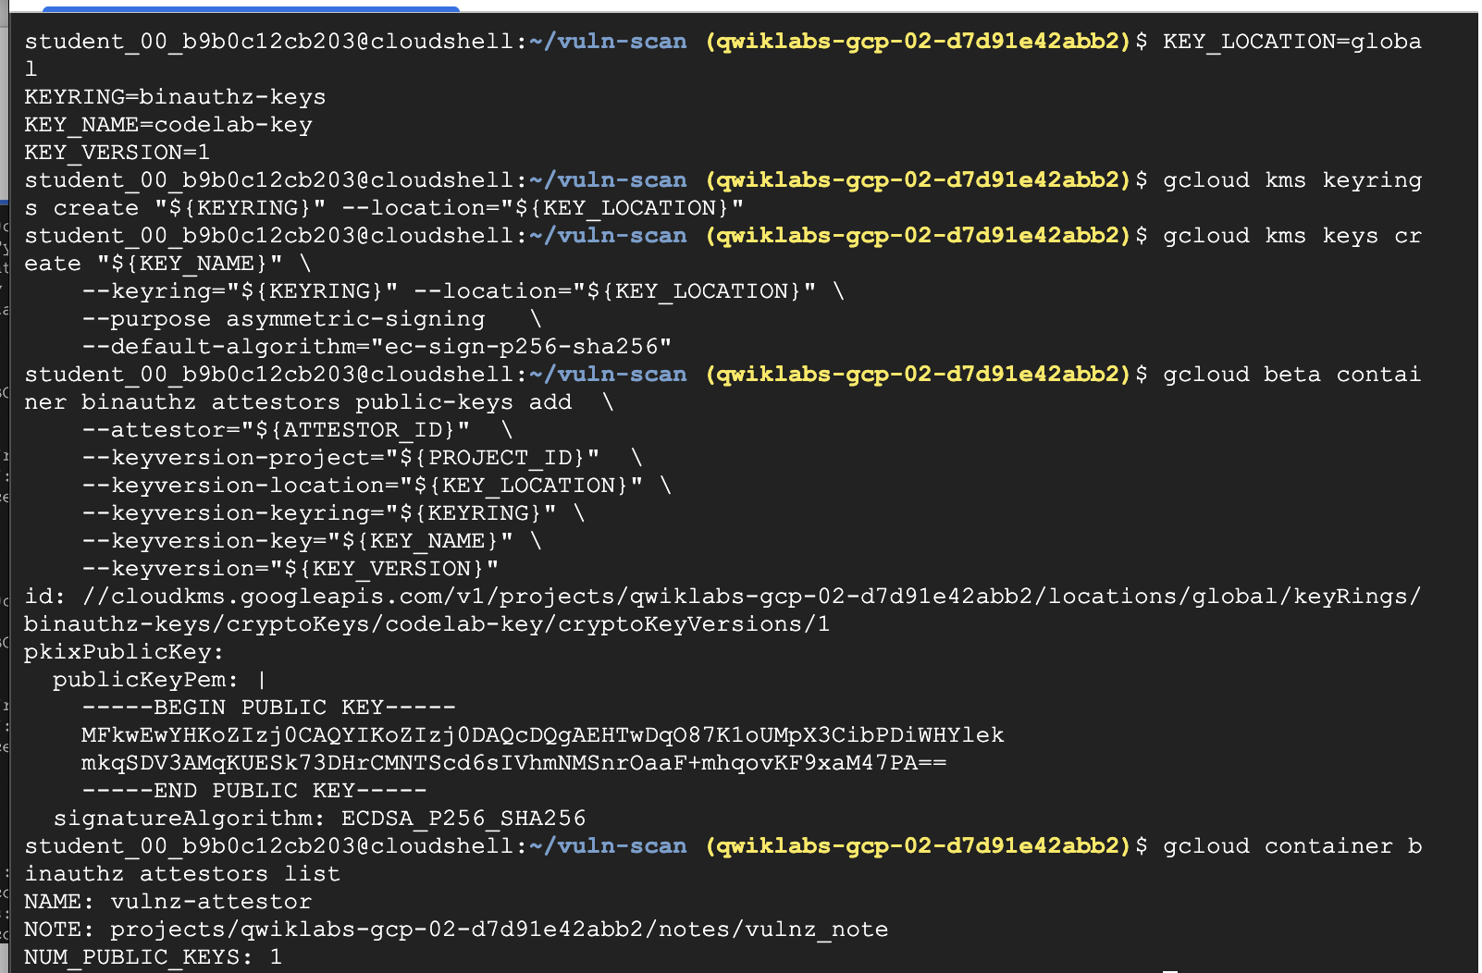

**Task 4. Creating a signed attestation**

At this point you have the features configured that enable you to sign images. Use the Attestor you created previously to sign the Container Image you've been working with.

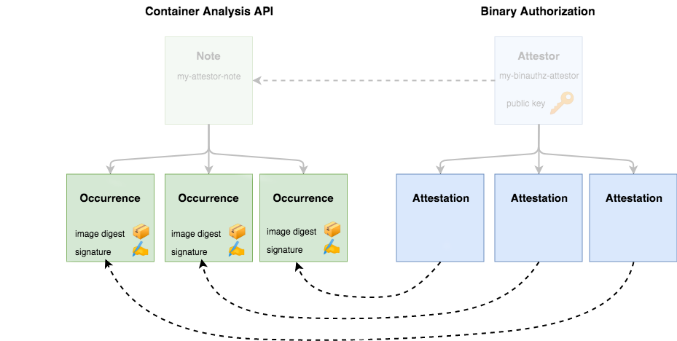

An attestation must include a cryptographic signature to state that the attestor has verified a particular container image and is safe to run on your cluster.

1. To specify which container image to attest, run the following to determine its digest:

CONTAINER\_PATH=europe-west1-docker.pkg.dev/${PROJECT\_ID}/artifact-scanning-repo/sample-image

Copied!

DIGEST=$(gcloud container images describe ${CONTAINER\_PATH}:latest \

--format='get(image\_summary.digest)')

Copied!

1. Now, you can use gcloud to create your attestation. The command takes in the details of the key you want to use for signing, and the specific container image you want to approve:

gcloud beta container binauthz attestations sign-and-create \

--artifact-url="${CONTAINER\_PATH}@${DIGEST}" \

--attestor="${ATTESTOR\_ID}" \

--attestor-project="${PROJECT\_ID}" \

--keyversion-project="${PROJECT\_ID}" \

--keyversion-location="${KEY\_LOCATION}" \

--keyversion-keyring="${KEYRING}" \

--keyversion-key="${KEY\_NAME}" \

--keyversion="${KEY\_VERSION}"

Copied!

In Container Analysis terms, this will create a new occurrence, and attach it to your attestor's note.

1. To ensure everything worked as expected, run the following to list your attestations:

gcloud container binauthz attestations list \

--attestor=$ATTESTOR\_ID --attestor-project=${PROJECT\_ID}

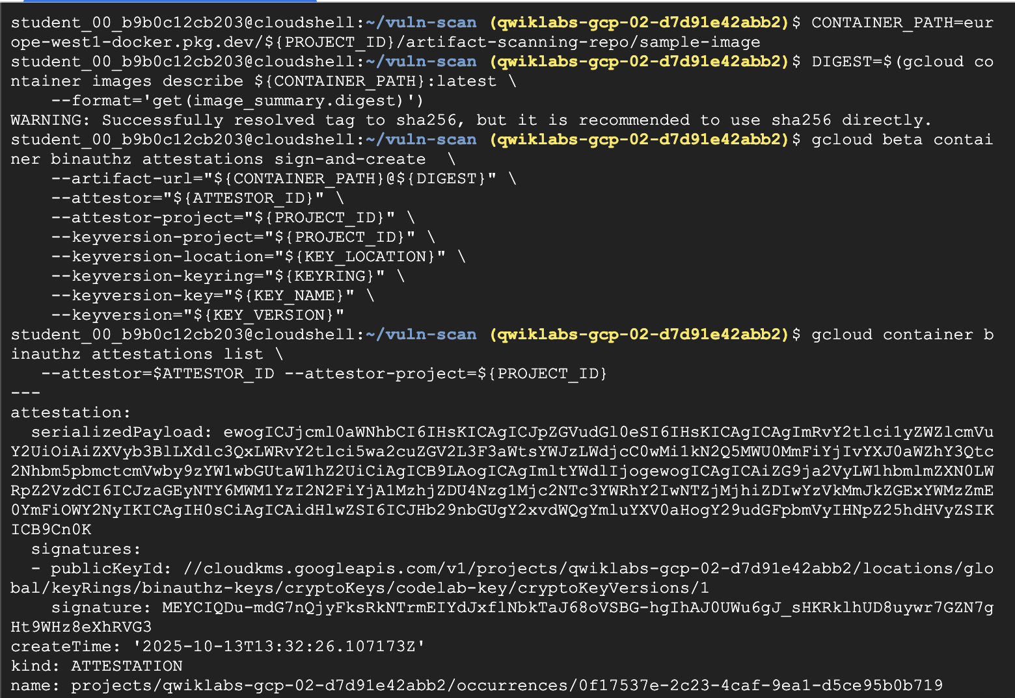**Task 5. Admission control policies**

[Binary Authorization](https://cloud.google.com/binary-authorization/docs/set-up-platform) is a feature in GKE and Cloud Run that provides the ability to validate rules before a container image is allowed to run. The validation executes on any request to run an image be it from a trusted CI/CD pipeline or a user manually trying to deploy an image. This capability allows you to secure your runtime environments more effectively than CI/CD pipeline checks alone.

To understand this capability you will modify the default GKE policy to enforce a strict authorization rule.

1. Create the GKE cluster with binary authorization enabled:

gcloud beta container clusters create binauthz \

--zone europe-west1-b \

--binauthz-evaluation-mode=PROJECT\_SINGLETON\_POLICY\_ENFORCE

Copied!

1. Allow Cloud Build to deploy to this cluster:

gcloud projects add-iam-policy-binding ${PROJECT\_ID} \

--member="serviceAccount:${PROJECT\_NUMBER}@cloudbuild.gserviceaccount.com" \

--role="roles/container.developer"

Copied!

Allow All policy

First verify the default policy state and your ability to deploy any image

1. Review existing policy:

gcloud container binauthz policy export

Copied!

1. Notice that the enforcement policy is set to ALWAYS\_ALLOW

evaluationMode: ALWAYS\_ALLOW

1. Deploy Sample to verify you can deploy anything:

kubectl run hello-server --image gcr.io/google-samples/hello-app:1.0 --port 8080

Copied!

1. Verify the deploy worked:

kubectl get pods

Copied!

You will see the following output:



1. Delete deployment:

kubectl delete pod hello-server

Copied!

Deny All policy

Now update the policy to disallow all images.

1. Export the current policy to an editable file:

gcloud container binauthz policy export > policy.yaml

Copied!

1. In a text editor, open the policy.yaml' file and change the evaluationMode from `ALWAYS\_ALLOW to **ALWAYS\_DENY**:

edit policy.yaml

Copied!

Ensure the edited policy YAML file appears as follows:

globalPolicyEvaluationMode: ENABLE

defaultAdmissionRule:

evaluationMode: ALWAYS\_DENY

enforcementMode: ENFORCED\_BLOCK\_AND\_AUDIT\_LOG

name: projects/PROJECT\_ID/policy

This policy is relatively simple. The *[globalPolicyEvaluationMode](https://cloud.google.com/binary-authorization/docs/policy-yaml-reference" \l "globalpolicyevaluationmode" \t "_blank)* line declares that this policy extends the global policy defined by Google. This allows all official GKE containers to run by default. Additionally, the policy declares a *[defaultAdmissionRule](https://cloud.google.com/binary-authorization/docs/policy-yaml-reference" \l "defaultadmissionrule" \t "_blank)* that states that all [other pods will be rejected](https://cloud.google.com/binary-authorization/docs/policy-yaml-reference#evaluationmode). The admission rule includes an [enforcementMode](https://cloud.google.com/binary-authorization/docs/policy-yaml-reference" \l "enforcementmode" \t "_blank) line, which states that all pods that are not conformant to this rule should be blocked from running on the cluster.

For instructions on how to build more complex policies, look through the [Binary Authorization documentation](https://cloud.google.com/binary-authorization/docs/policy-yaml-reference).

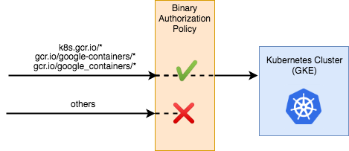

1. In Cloud Shell run the following to apply the new policy:

gcloud container binauthz policy import policy.yaml

Copied!

Wait a few seconds for the change to propagate.

1. Attempt a sample workload deployment:

kubectl run hello-server --image gcr.io/google-samples/hello-app:1.0 --port 8080

Copied!

1. Deployment fails with the following message:

Error from server (VIOLATES\_POLICY): admission webhook "imagepolicywebhook.image-policy.k8s.io" denied the request: Image gcr.io/google-samples/hello-app:1.0 denied by Binary Authorization default admission rule. Denied by always\_deny admission rule

Revert the policy to allow all

Before moving on to the next section, revert the policy changes.

1. In a text editor, change the evaluationMode from ALWAYS\_DENY to **ALWAYS\_ALLOW**.

edit policy.yaml

Copied!

The edited policy YAML file should appear as follows:

globalPolicyEvaluationMode: ENABLE

defaultAdmissionRule:

evaluationMode: ALWAYS\_ALLOW

enforcementMode: ENFORCED\_BLOCK\_AND\_AUDIT\_LOG

name: projects/PROJECT\_ID/policy

1. Apply the reverted policy:

gcloud container binauthz policy import policy.yaml

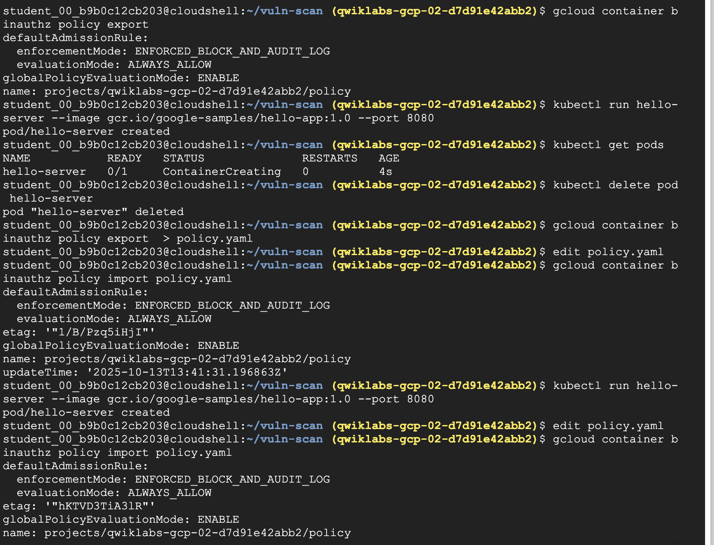

**Task 6. Automatically signing images**

You've enabled image signing, and manually used the Attestor to sign your sample image. In practice you will want to apply attestations during automated processes such as CI/CD pipelines.

In this section you will configure [Cloud Build](https://cloud.google.com/binary-authorization/docs/cloud-build) to attest images automatically.

Roles needed

1. Add Binary Authorization Attestor Viewer role to Cloud Build Service Account:

gcloud projects add-iam-policy-binding ${PROJECT\_ID} \

--member serviceAccount:${PROJECT\_NUMBER}@cloudbuild.gserviceaccount.com \

--role roles/binaryauthorization.attestorsViewer

Copied!

1. Add Cloud KMS CryptoKey Signer/Verifier role to Cloud Build Service Account (KMS-based Signing):

gcloud projects add-iam-policy-binding ${PROJECT\_ID} \

--member serviceAccount:${PROJECT\_NUMBER}@cloudbuild.gserviceaccount.com \

--role roles/cloudkms.signerVerifier

Copied!

gcloud projects add-iam-policy-binding ${PROJECT\_ID} \

--member serviceAccount:${PROJECT\_NUMBER}-compute@developer.gserviceaccount.com \

--role roles/cloudkms.signerVerifier

Copied!

1. Add Container Analysis Notes Attacher role to Cloud Build Service Account:

gcloud projects add-iam-policy-binding ${PROJECT\_ID} \

--member serviceAccount:${PROJECT\_NUMBER}@cloudbuild.gserviceaccount.com \

--role roles/containeranalysis.notes.attacher

Copied!

Provide access for Cloud Build Service Account

Cloud Build will need rights to access the on-demand scanning api.

* Provide access with the following commands:

gcloud projects add-iam-policy-binding ${PROJECT\_ID} \

--member="serviceAccount:${PROJECT\_NUMBER}@cloudbuild.gserviceaccount.com" \

--role="roles/iam.serviceAccountUser"

gcloud projects add-iam-policy-binding ${PROJECT\_ID} \

--member="serviceAccount:${PROJECT\_NUMBER}@cloudbuild.gserviceaccount.com" \

--role="roles/ondemandscanning.admin"

Copied!

Prepare the Custom Build Cloud Build Step

You'll be using a Custom Build step in Cloud Build to simplify the attestation process. Google provides this Custom Build step which contains helper functions to streamline the process. Before use, the code for the custom build step must be built into a container and pushed to Cloud Build.

* To do this, run the following commands:

git clone https://github.com/GoogleCloudPlatform/cloud-builders-community.git

cd cloud-builders-community/binauthz-attestation

gcloud builds submit . --config cloudbuild.yaml

cd ../..

rm -rf cloud-builders-community

Copied!

Add a signing step to your cloudbuild.yaml

Add the attestation step into your Cloud Build pipeline.

1. Review the signing step below.

**Review only. Do Not Copy**

#Sign the image only if the previous severity check passes

- id: 'create-attestation'

name: 'gcr.io/${PROJECT\_ID}/binauthz-attestation:latest'

args:

- '--artifact-url'

- '{{{ project\_0.default\_region | "REGION" }}}-docker.pkg.dev/${PROJECT\_ID}/artifact-scanning-repo/sample-image'

- '--attestor'

- 'projects/${PROJECT\_ID}/attestors/$ATTESTOR\_ID'

- '--keyversion'

- 'projects/${PROJECT\_ID}/locations/$KEY\_LOCATION/keyRings/$KEYRING/cryptoKeys/$KEY\_NAME/cryptoKeyVersions/$KEY\_VERSION'

Copied!

1. Write a cloudbuild.yaml file with the complete pipeline below:

cat > ./cloudbuild.yaml << EOF

steps:

# build

- id: "build"

name: 'gcr.io/cloud-builders/docker'

args: ['build', '-t', 'europe-west1-docker.pkg.dev/${PROJECT\_ID}/artifact-scanning-repo/sample-image', '.']

waitFor: ['-']

# additional CICD checks (not shown)

#Retag

- id: "retag"

name: 'gcr.io/cloud-builders/docker'

args: ['tag', 'europe-west1-docker.pkg.dev/${PROJECT\_ID}/artifact-scanning-repo/sample-image', 'europe-west1-docker.pkg.dev/${PROJECT\_ID}/artifact-scanning-repo/sample-image:good']

#pushing to artifact registry

- id: "push"

name: 'gcr.io/cloud-builders/docker'

args: ['push', 'europe-west1-docker.pkg.dev/${PROJECT\_ID}/artifact-scanning-repo/sample-image:good']

#Sign the image only if the previous severity check passes

- id: 'create-attestation'

name: 'gcr.io/${PROJECT\_ID}/binauthz-attestation:latest'

args:

- '--artifact-url'

- 'europe-west1-docker.pkg.dev/${PROJECT\_ID}/artifact-scanning-repo/sample-image:good'

- '--attestor'

- 'projects/${PROJECT\_ID}/attestors/$ATTESTOR\_ID'

- '--keyversion'

- 'projects/${PROJECT\_ID}/locations/$KEY\_LOCATION/keyRings/$KEYRING/cryptoKeys/$KEY\_NAME/cryptoKeyVersions/$KEY\_VERSION'

images:

- europe-west1-docker.pkg.dev/${PROJECT\_ID}/artifact-scanning-repo/sample-image:good

EOF

Copied!

1. Run the build:

gcloud builds submit

Copied!

Review the build in Cloud Build History

In the Cloud console navigate to **Cloud Build > Build history** page and review that latest build and the successful execution of the build steps.

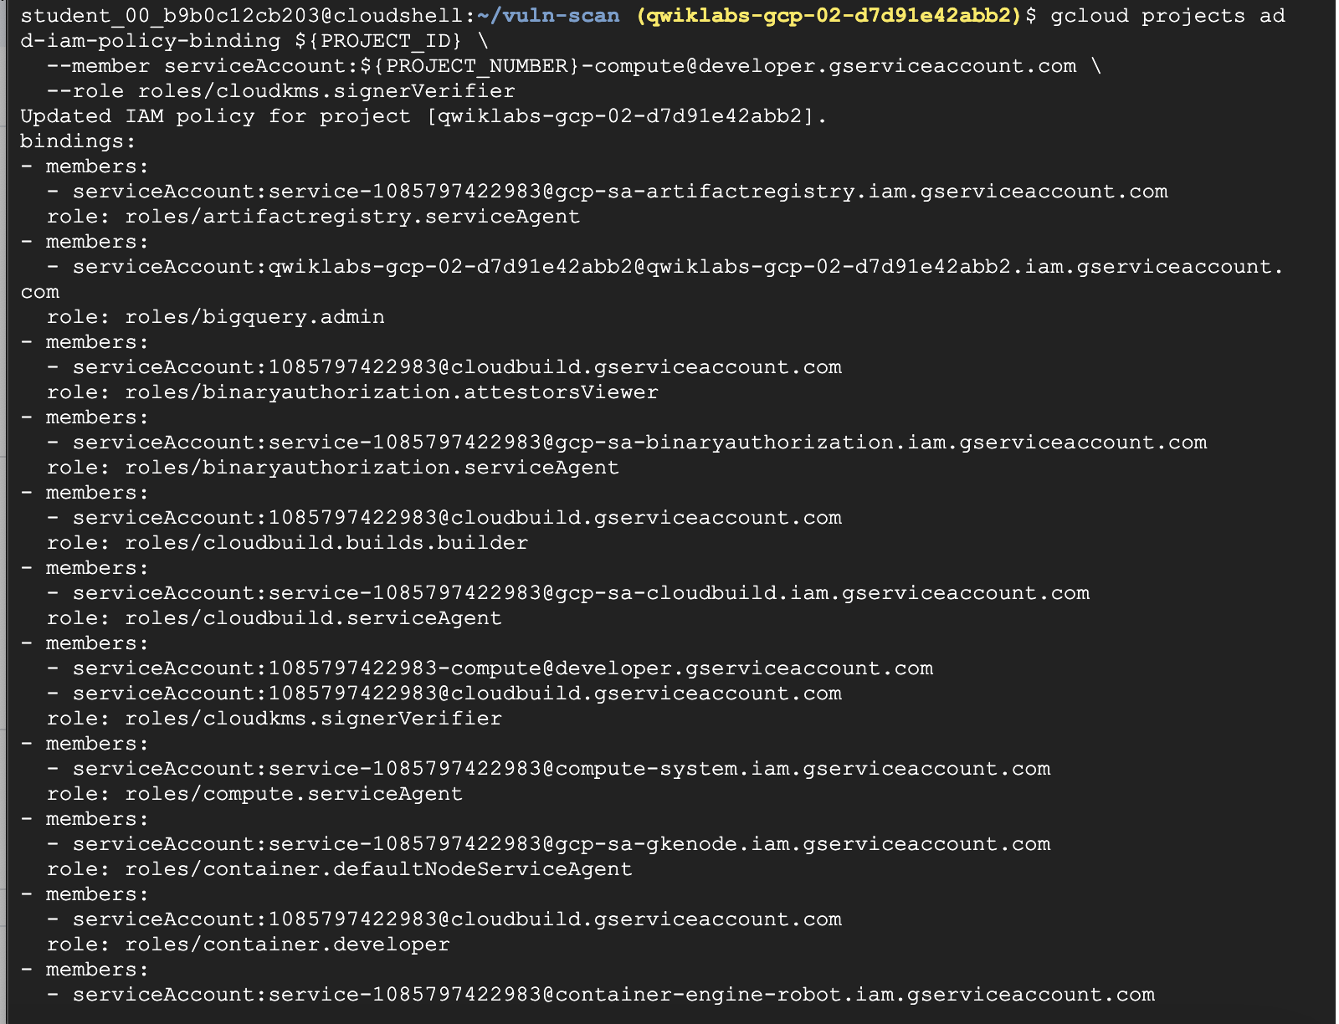 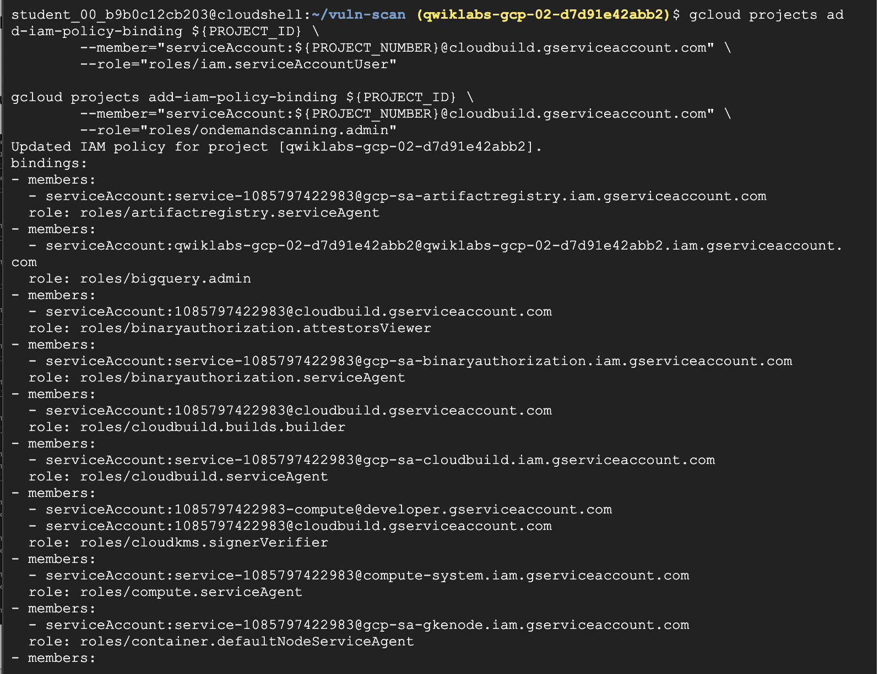 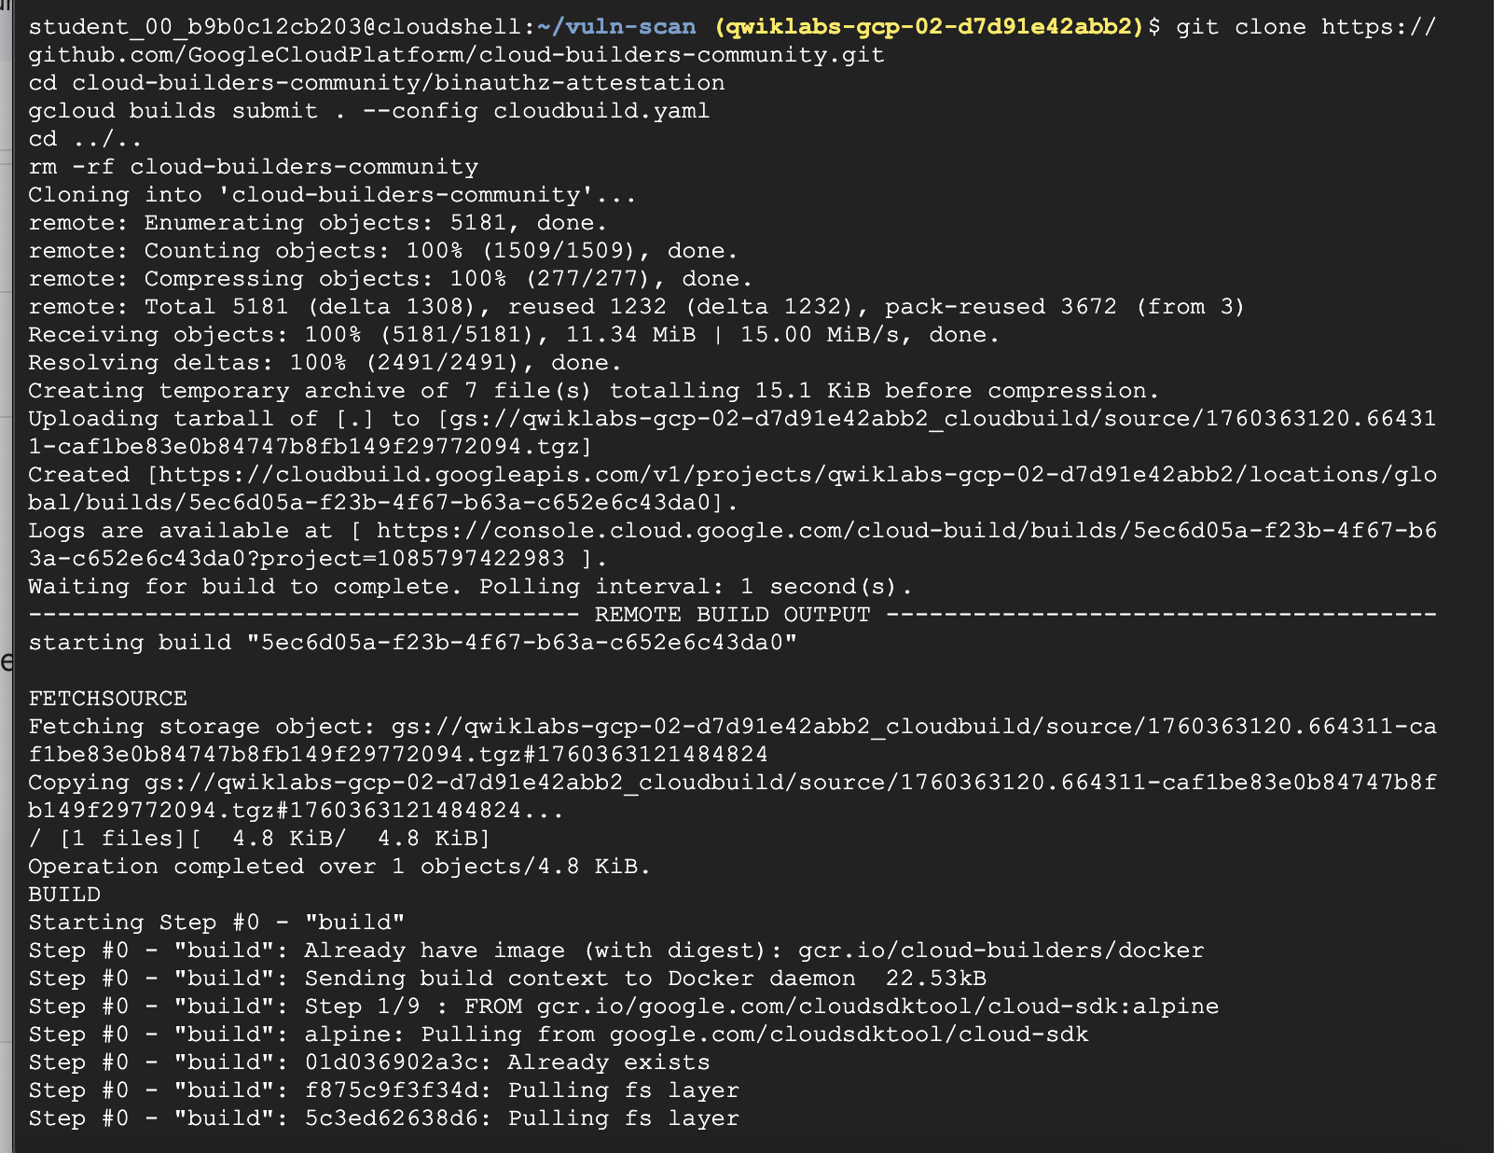 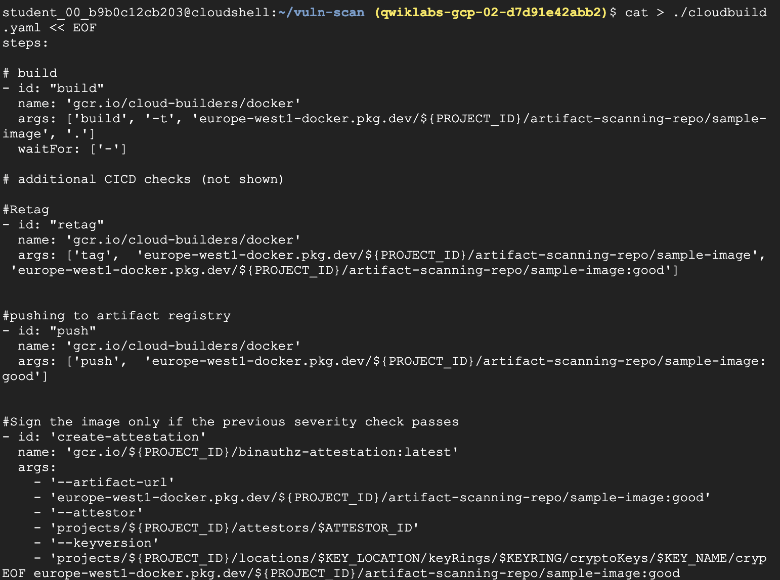 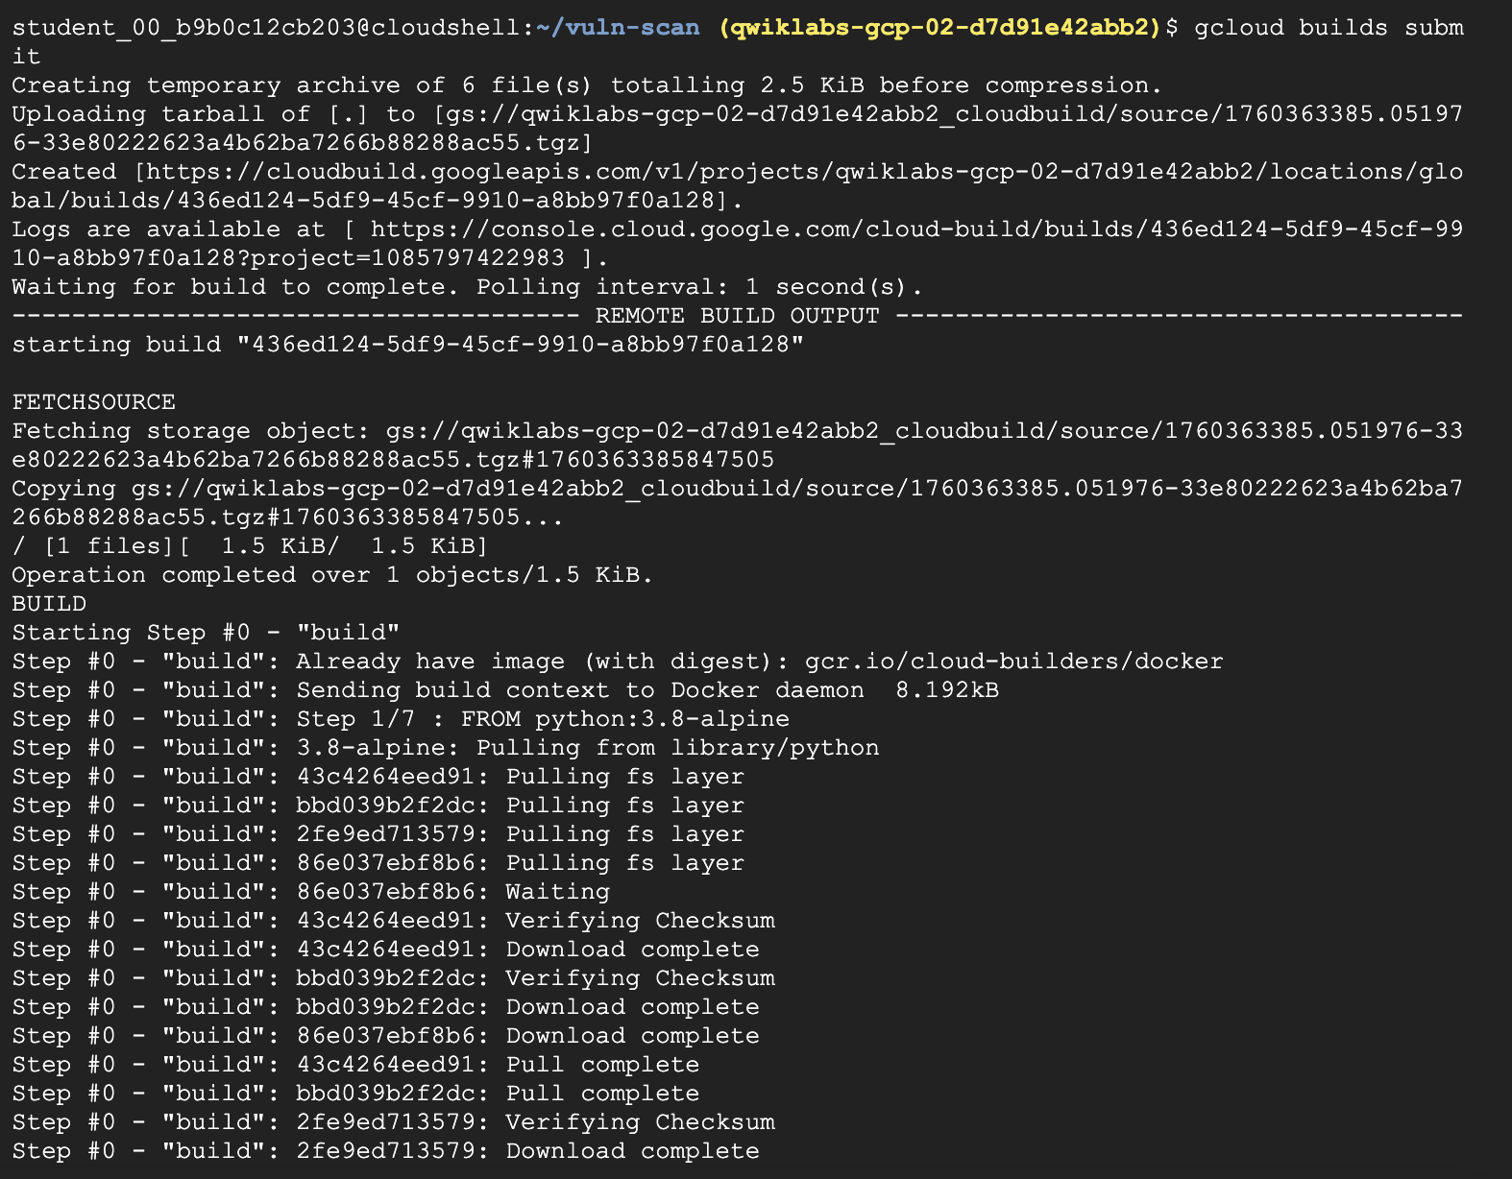

**Task 7. Authorizing signed images**

Now you will update GKE to use Binary Authorization for validating the image has a signature from the Vulnerability scanning before allowing the image to run.

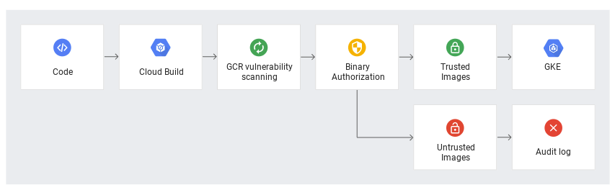

Update GKE Policy to Require Attestation

Require images are signed by your Attestor by adding clusterAdmissionRules to your GKE BinAuth Policy

Currently, your cluster is running a policy with one rule: allow containers from official repositories, and reject all others.

1. Overwrite the policy with the updated config using the command below:

COMPUTE\_ZONE=europe-west1

cat > binauth\_policy.yaml << EOM

defaultAdmissionRule:

enforcementMode: ENFORCED\_BLOCK\_AND\_AUDIT\_LOG

evaluationMode: REQUIRE\_ATTESTATION

requireAttestationsBy:

- projects/${PROJECT\_ID}/attestors/vulnz-attestor

globalPolicyEvaluationMode: ENABLE

clusterAdmissionRules:

${COMPUTE\_ZONE}.binauthz:

evaluationMode: REQUIRE\_ATTESTATION

enforcementMode: ENFORCED\_BLOCK\_AND\_AUDIT\_LOG

requireAttestationsBy:

- projects/${PROJECT\_ID}/attestors/vulnz-attestor

EOM

Copied!

1. You should now have a new file on disk, called updated\_policy.yaml. Now, instead of the default rule rejecting all images, it first checks your attestor for verifications.

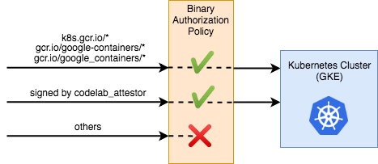

1. Upload the new policy to Binary Authorization:

gcloud beta container binauthz policy import binauth\_policy.yaml

Copied!

Deploy a signed image

1. Get the image digest for the good image:

CONTAINER\_PATH=europe-west1-docker.pkg.dev/${PROJECT\_ID}/artifact-scanning-repo/sample-image

Copied!

DIGEST=$(gcloud container images describe ${CONTAINER\_PATH}:good \

--format='get(image\_summary.digest)')

Copied!

1. Use the digest in the Kubernetes configuration:

cat > deploy.yaml << EOM

apiVersion: v1

kind: Service

metadata:

name: deb-httpd

spec:

selector:

app: deb-httpd

ports:

- protocol: TCP

port: 80

targetPort: 8080

---

apiVersion: apps/v1

kind: Deployment

metadata:

name: deb-httpd

spec:

replicas: 1

selector:

matchLabels:

app: deb-httpd

template:

metadata:

labels:

app: deb-httpd

spec:

containers:

- name: deb-httpd

image: ${CONTAINER\_PATH}@${DIGEST}

ports:

- containerPort: 8080

env:

- name: PORT

value: "8080"

EOM

Copied!

1. Deploy the app to GKE

kubectl apply -f deploy.yaml

Copied!

In the Cloud console navigate to **Kubernetes Engine > Workloads** and review the successful deployment of the image. 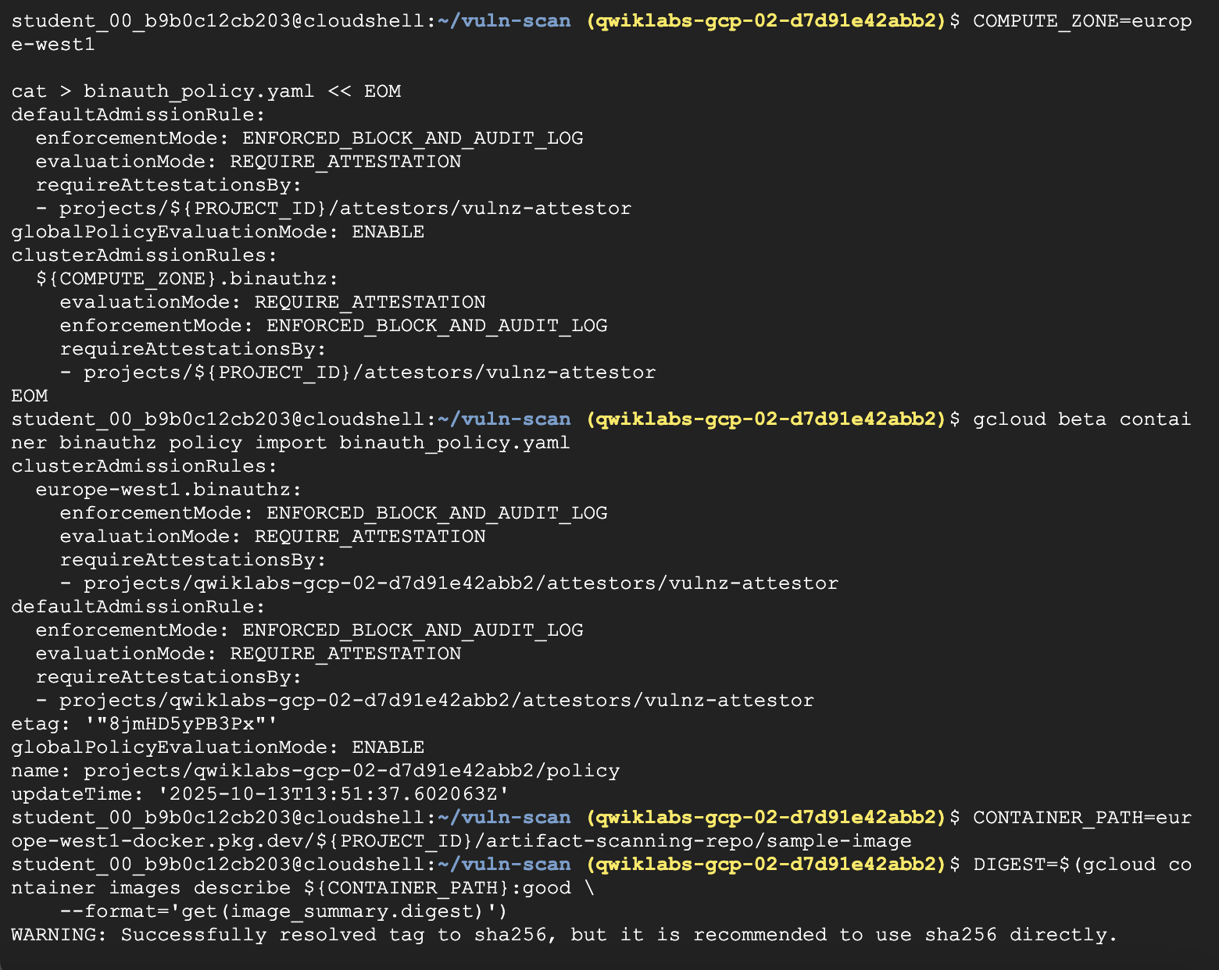 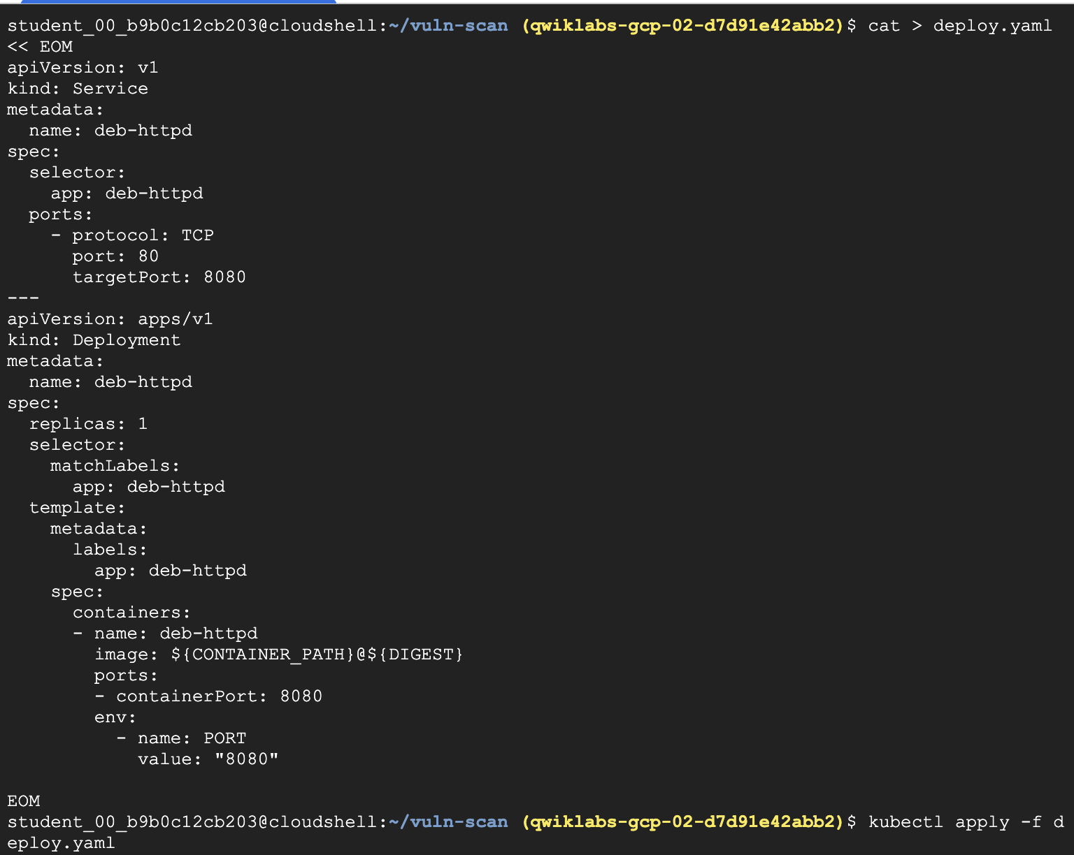 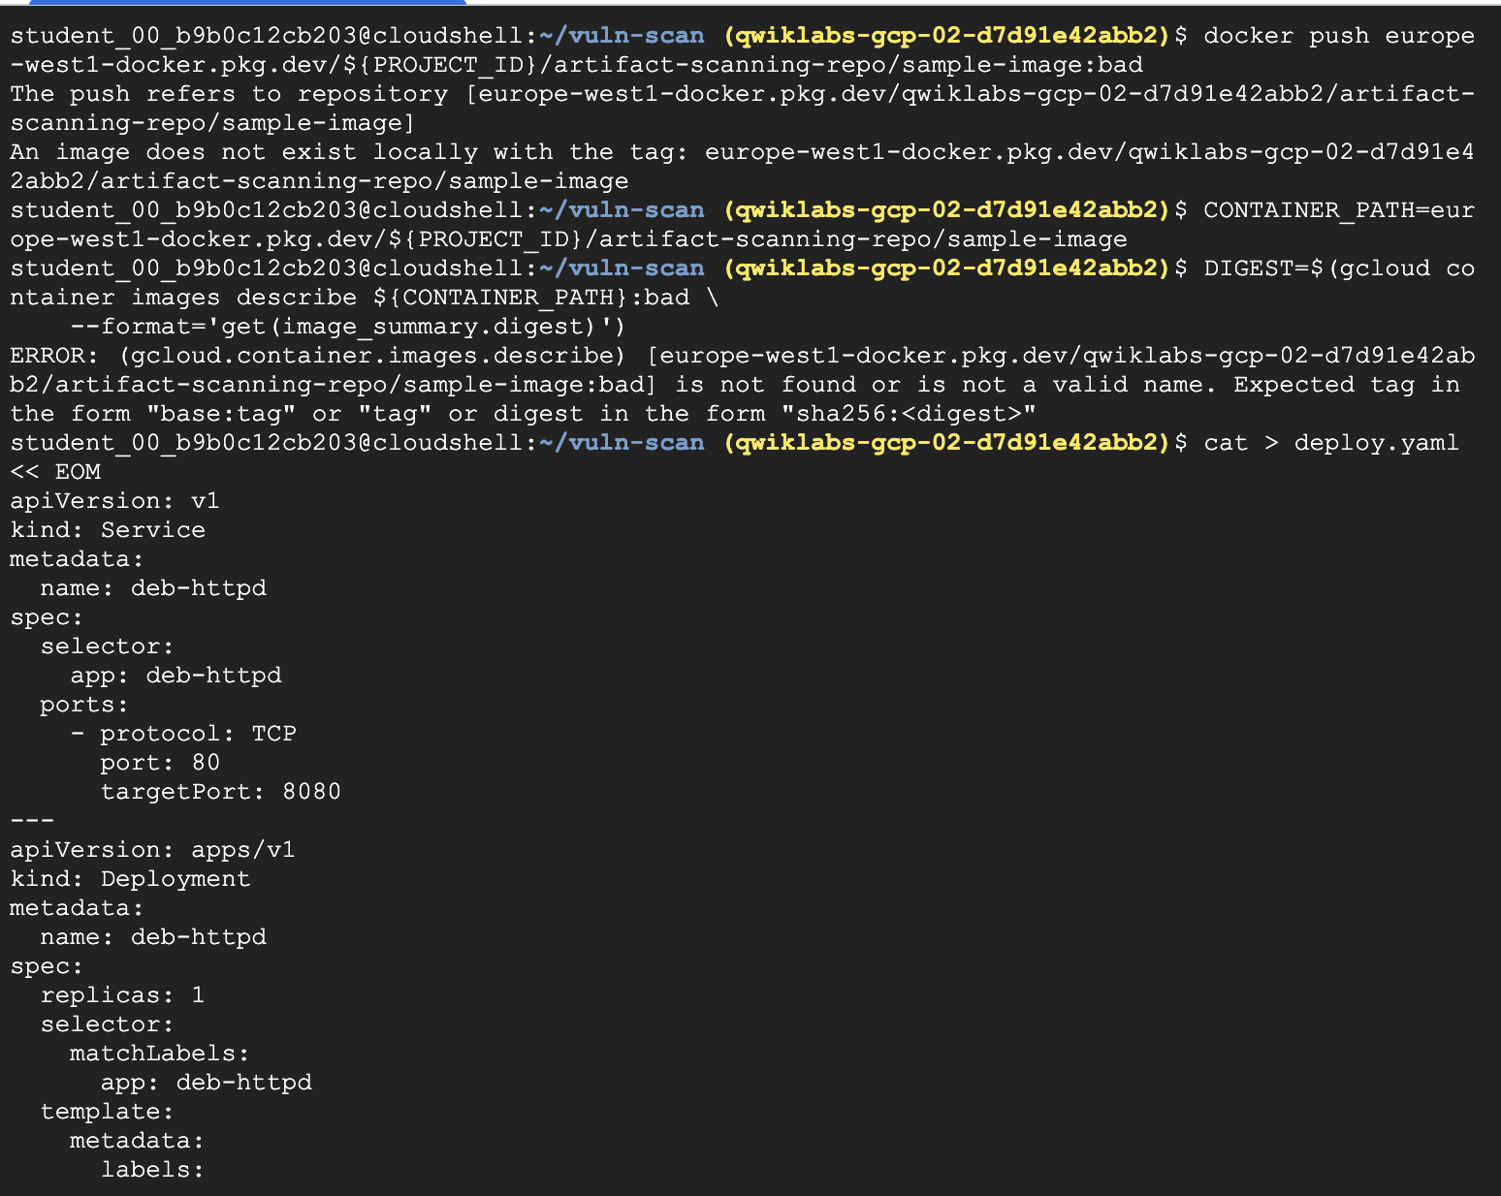 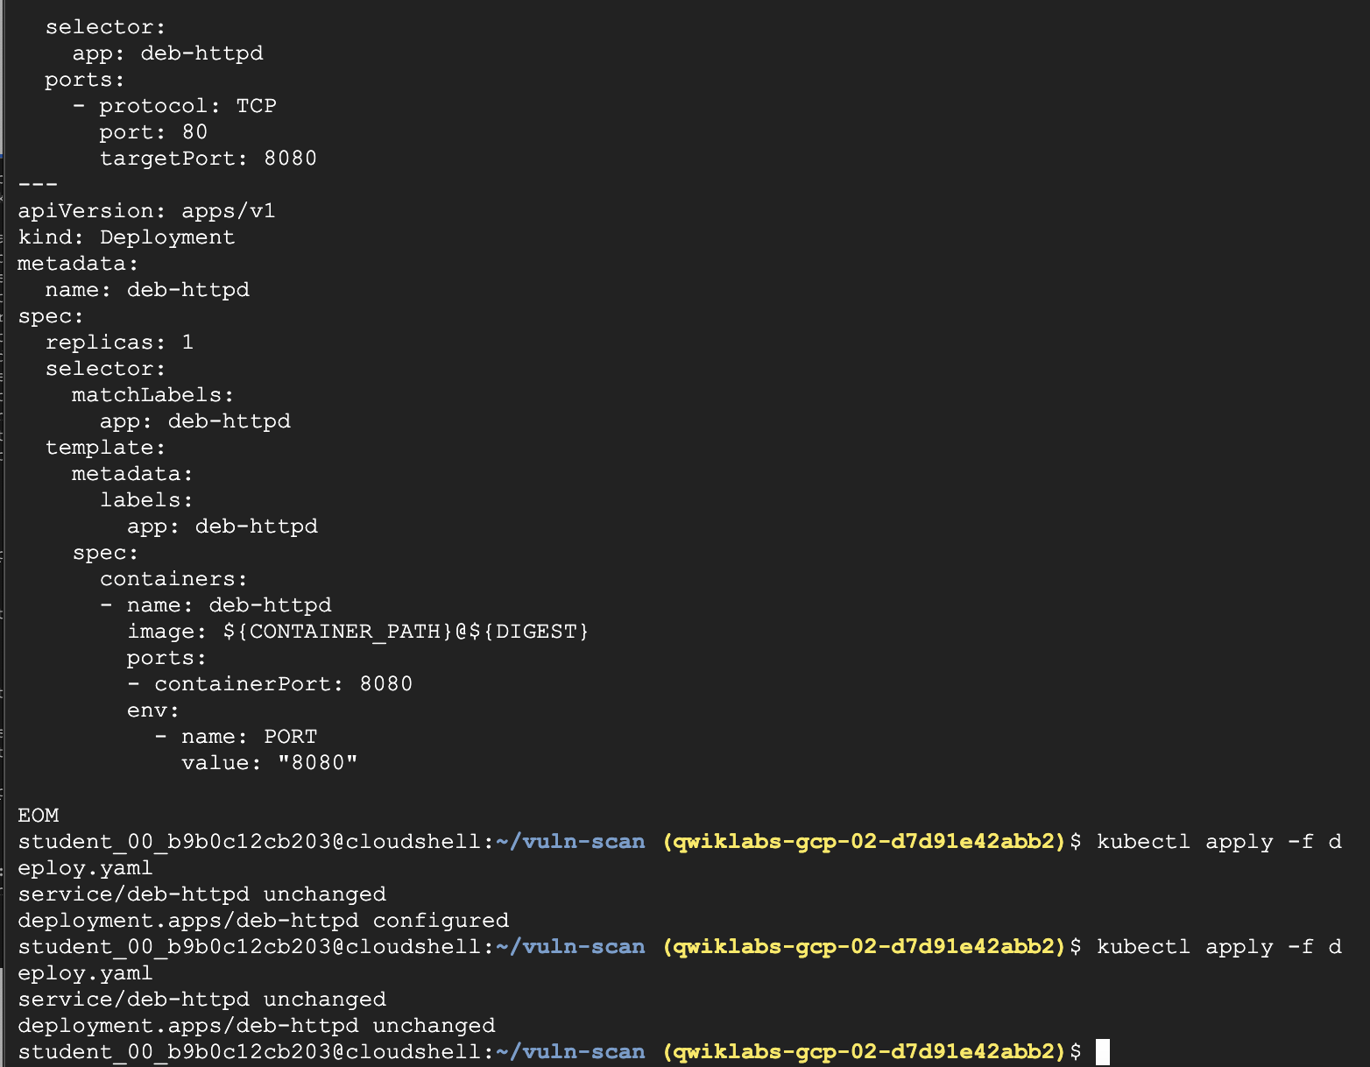

**Task 8. Blocked unsigned Images**

Build an Image

1. Use local docker to build the image to your local cache:

docker build -t europe-west1-docker.pkg.dev/${PROJECT\_ID}/artifact-scanning-repo/sample-image:bad .

Copied!

1. Push the unsigned image to the repo:

docker push europe-west1-docker.pkg.dev/${PROJECT\_ID}/artifact-scanning-repo/sample-image:bad

Copied!

1. Get the image digest for the bad image:

CONTAINER\_PATH=europe-west1-docker.pkg.dev/${PROJECT\_ID}/artifact-scanning-repo/sample-image

Copied!

DIGEST=$(gcloud container images describe ${CONTAINER\_PATH}:bad \

--format='get(image\_summary.digest)')

Copied!

1. Use the digest in the Kubernetes configuration:

cat > deploy.yaml << EOM

apiVersion: v1

kind: Service

metadata:

name: deb-httpd

spec:

selector:

app: deb-httpd

ports:

- protocol: TCP

port: 80

targetPort: 8080

---

apiVersion: apps/v1

kind: Deployment

metadata:

name: deb-httpd

spec:

replicas: 1

selector:

matchLabels:

app: deb-httpd

template:

metadata:

labels:

app: deb-httpd

spec:

containers:

- name: deb-httpd

image: ${CONTAINER\_PATH}@${DIGEST}

ports:

- containerPort: 8080

env:

- name: PORT

value: "8080"

EOM

Copied!

1. Attempt to deploy the app to GKE

kubectl apply -f deploy.yaml

Copied!

Review the [workload in the console](https://console.cloud.google.com/kubernetes/workload/overview) and note the error stating the deployment was denied:

No attestations found that were valid and signed by a key trusted by the attestor